AECHE => ATCHE Organic Chemistry 2021
Consider the following SCSA syllabus objective:
- IUPAC nomenclature is used to name organic species, including those with a parent chain of up to
8 carbon atoms with simple branching and one of the following functional groups: alkenes, alcohols, aldehydes, ketones, carboxylic acids, esters, amines and amides

Alkenes – double bonds. Just like what was in the year 11 course. Do not forget the geometric isomers.
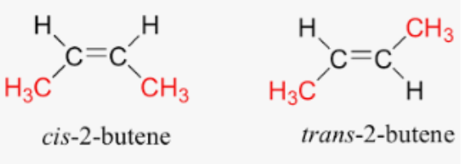
Alcohols – “… ol” - 3 types (look at the carbon where the –OH is attached):
- Primary
- Secondary
- Tertiary
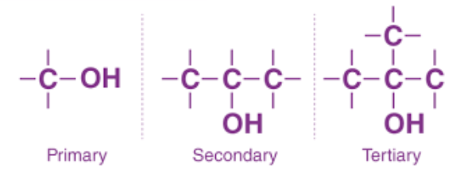
Aldehydes - “… al” - the = O is attached to an end carbon (terminal carbon)
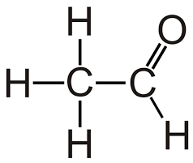
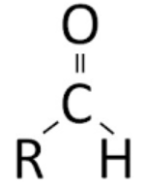 Ethanal

Ketones - “… one”– this is when the = O is attach to a non-end carbon (non-terminal carbon)

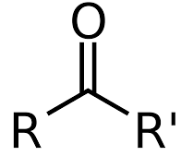 Propanone 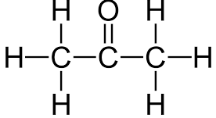

Carboxylic acids – “… oic acid” – this is when a = O and –OH are on the same carbon. Typical acidic properties and reactions.
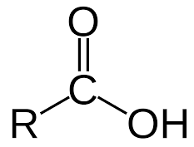 Propanoic acid 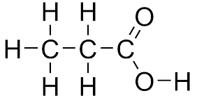

Esters – “… oate” – this is when the carbon chain has an oxygen within the chain itself and there is a = O located on a carbon right next to the oxygen that is in the chain. The diagram makes it less confusing.
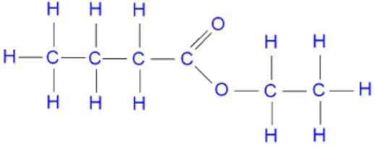
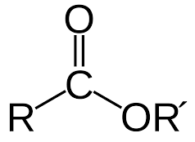 Ethyl butanoate

Amines – “… amine” – three types like alcohols
- Primary
- Secondary
- Tertiary
As per:
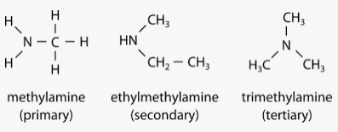
Amides – “… amide”

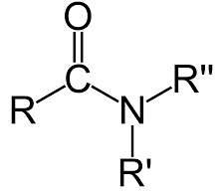 methyl propanamide 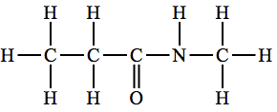
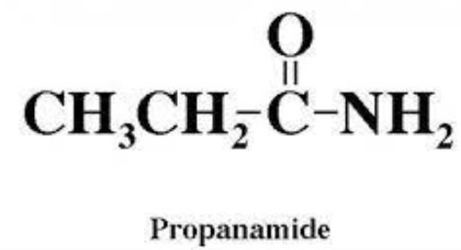 ethyl butanamide 